Contenido

BOOTSTRAP 2

Links 2

Buttons 3

Cards 5

**Titles, text, and links** 6

**Images** 7

**List groups** 8

**Kitchen sink** 9

**Using grid markup** 10

Navigation 13

Images 14

**Image caps** 14

**Image overlays** 15

**Background and color** 16

**Border** 18

Card layout 20

**Card groups** 21

**Grid cards** 22

Carousel 26

**With controls** 26

**With indicators** 27

**With captions** 28

Accordion example 30

Jumbotron 32

Navs 33

**Horizontal alignment** 33

**Tabs** 34

Navbar 36

# BOOTSTRAP

## Links

Using the contextual .badge-* classes on an <a> element quickly provide *actionable* badges with hover and focus states.

[**Primary**](https://getbootstrap.com/docs/4.4/components/badge/) **[Secondary](https://getbootstrap.com/docs/4.4/components/badge/)** **[Success](https://getbootstrap.com/docs/4.4/components/badge/)** **[Danger](https://getbootstrap.com/docs/4.4/components/badge/)** **[Warning](https://getbootstrap.com/docs/4.4/components/badge/)** **[Info](https://getbootstrap.com/docs/4.4/components/badge/)** [**Light**](https://getbootstrap.com/docs/4.4/components/badge/) **[Dark](https://getbootstrap.com/docs/4.4/components/badge/)**

Copy

<a href="#" class="badge badge-primary">Primary</a>

<a href="#" class="badge badge-secondary">Secondary</a>

<a href="#" class="badge badge-success">Success</a>

<a href="#" class="badge badge-danger">Danger</a>

<a href="#" class="badge badge-warning">Warning</a>

<a href="#" class="badge badge-info">Info</a>

<a href="#" class="badge badge-light">Light</a>

<a href="#" class="badge badge-dark">Dark</a>

## Buttons

Use Bootstrap’s custom button styles for actions in forms, dialogs, and more with support for multiple sizes, states, and more.

Examples

Bootstrap includes several predefined button styles, each serving its own semantic purpose, with a few extras thrown in for more control.



<button type="button" class="btn btn-primary">Primary</button>

<button type="button" class="btn btn-secondary">Secondary</button>

<button type="button" class="btn btn-success">Success</button>

<button type="button" class="btn btn-danger">Danger</button>

<button type="button" class="btn btn-warning">Warning</button>

<button type="button" class="btn btn-info">Info</button>

<button type="button" class="btn btn-light">Light</button>

<button type="button" class="btn btn-dark">Dark</button>

<button type="button" class="btn btn-link">Link</button>

**Outline buttons**

In need of a button, but not the hefty background colors they bring? Replace the default modifier classes with the .btn-outline-* ones to remove all background images and colors on any button.

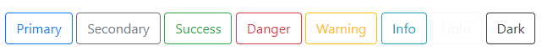

<button type="button" class="btn btn-outline-primary">Primary</button>

<button type="button" class="btn btn-outline-secondary">Secondary</button>

<button type="button" class="btn btn-outline-success">Success</button>

<button type="button" class="btn btn-outline-danger">Danger</button>

<button type="button" class="btn btn-outline-warning">Warning</button>

<button type="button" class="btn btn-outline-info">Info</button>

<button type="button" class="btn btn-outline-light">Light</button>

<button type="button" class="btn btn-outline-dark">Dark</button>

## Cards

Bootstrap’s cards provide a flexible and extensible content container with multiple variants and options.

**ABOUT**

A **card** is a flexible and extensible content container. It includes options for headers and footers, a wide variety of content, contextual background colors, and powerful display options. If you’re familiar with Bootstrap 3, cards replace our old panels, wells, and thumbnails. Similar functionality to those components is available as modifier classes for cards.

**EXAMPLE**

Cards are built with as little markup and styles as possible, but still manage to deliver a ton of control and customization. Built with flexbox, they offer easy alignment and mix well with other Bootstrap components. They have no margin by default, so use [spacing utilities](https://getbootstrap.com/docs/4.4/utilities/spacing/) as needed.

Below is an example of a basic card with mixed content and a fixed width. Cards have no fixed width to start, so they’ll naturally fill the full width of its parent element. This is easily customized with our various [sizing options](https://getbootstrap.com/docs/4.4/components/card/" \l "sizing).

Image cap

##### **Card title**

Some quick example text to build on the card title and make up the bulk of the card's content.

<div class="card" style="width: 18rem;">

<img src="..." class="card-img-top" alt="...">

<div class="card-body">

<h5 class="card-title">Card title</h5>

<p class="card-text">Some quick example text to build on the card title and make up the bulk of the card's content.</p>

<a href="#" class="btn btn-primary">Go somewhere</a>

</div>

</div>

### **HEADER AND FOOTER**

Add an optional header and/or footer within a card.

<div class="card">

<div class="card-header">

Featured

</div>

<div class="card-body">

<h5 class="card-title">Special title treatment</h5>

<p class="card-text">With supporting text below as a natural lead-in to additional content.</p>

<a href="#" class="btn btn-primary">Go somewhere</a>

</div>

</div>

<div class="card">

<div class="card-header">

Quote

</div>

<div class="card-body">

<blockquote class="blockquote mb-0">

<p>Lorem ipsum dolor sit amet, consectetur adipiscing elit. Integer posuere erat a ante.</p>

<footer class="blockquote-footer">Someone famous in <cite title="Source Title">Source Title</cite></footer>

</blockquote>

</div>

</div>

### **USING GRID MARKUP**

Using the grid, wrap cards in columns and rows as needed.

<div class="row">

<div class="col-sm-6">

<div class="card">

<div class="card-body">

<h5 class="card-title">Special title treatment</h5>

<p class="card-text">With supporting text below as a natural lead-in to additional content.</p>

<a href="#" class="btn btn-primary">Go somewhere</a>

</div>

</div>

</div>

<div class="col-sm-6">

<div class="card">

<div class="card-body">

<h5 class="card-title">Special title treatment</h5>

<p class="card-text">With supporting text below as a natural lead-in to additional content.</p>

<a href="#" class="btn btn-primary">Go somewhere</a>

</div>

</div>

</div>

</div>

### **Using utilities**

Use our handful of [available sizing utilities](https://getbootstrap.com/docs/4.0/utilities/sizing/) to quickly set a card’s width.

<div class="card w-75">

<div class="card-body">

<h5 class="card-title">Card title</h5>

<p class="card-text">With supporting text below as a natural lead-in to additional content.</p>

<a href="#" class="btn btn-primary">Button</a>

</div>

</div>

<div class="card w-50">

<div class="card-body">

<h5 class="card-title">Card title</h5>

<p class="card-text">With supporting text below as a natural lead-in to additional content.</p>

<a href="#" class="btn btn-primary">Button</a>

</div>

</div>

### **Titles, text, and links**

Card titles are used by adding .card-title to a <h*> tag. In the same way, links are added and placed next to each other by adding .card-link to an <a> tag.

Subtitles are used by adding a .card-subtitle to a <h*> tag. If the .card-title and the .card-subtitle items are placed in a .card-body item, the card title and subtitle are aligned nicely.

##### **Card title**

###### **Card subtitle**

Some quick example text to build on the card title and make up the bulk of the card's content.

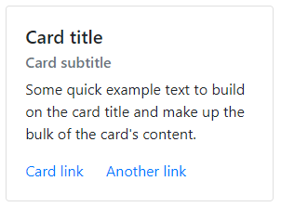

<div class="card" style="width: 18rem;">

<div class="card-body">

<h5 class="card-title">Card title</h5>

<h6 class="card-subtitle mb-2 text-muted">Card subtitle</h6>

<p class="card-text">Some quick example text to build on the card title and make up the bulk of the card's content.</p>

<a href="#" class="card-link">Card link</a>

<a href="#" class="card-link">Another link</a>

</div>

</div>

### **Images**

.card-img-top places an image to the top of the card. With .card-text, text can be added to the card. Text within .card-text can also be styled with the standard HTML tags.

Image cap

Some quick example text to build on the card title and make up the bulk of the card's content.

<div class="card" style="width: 18rem;">

<img src="..." class="card-img-top" alt="...">

<div class="card-body">

<p class="card-text">Some quick example text to build on the card title and make up the bulk of the card's content.</p>

</div>

</div>

### **List groups**

Create lists of content in a card with a flush list group.

<div class="card" style="width: 18rem;">

<ul class="list-group list-group-flush">

<li class="list-group-item">Cras justo odio</li>

<li class="list-group-item">Dapibus ac facilisis in</li>

<li class="list-group-item">Vestibulum at eros</li>

</ul>

</div>

### **Kitchen sink**

Mix and match multiple content types to create the card you need, or throw everything in there. Shown below are image styles, blocks, text styles, and a list group—all wrapped in a fixed-width card.

<div class="card" style="width: 18rem;">

<img src="..." class="card-img-top" alt="...">

<div class="card-body">

<h5 class="card-title">Card title</h5>

<p class="card-text">Some quick example text to build on the card title and make up the bulk of the card's content.</p>

</div>

<ul class="list-group list-group-flush">

<li class="list-group-item">Cras justo odio</li>

<li class="list-group-item">Dapibus ac facilisis in</li>

<li class="list-group-item">Vestibulum at eros</li>

</ul>

<div class="card-body">

<a href="#" class="card-link">Card link</a>

<a href="#" class="card-link">Another link</a>

</div>

</div>

**Sizing**

Cards assume no specific width to start, so they’ll be 100% wide unless otherwise stated. You can change this as needed with custom CSS, grid classes, grid Sass mixins, or utilities.

### **Using grid markup**

Using the grid, wrap cards in columns and rows as needed.

<div class="row">

<div class="col-sm-6">

<div class="card">

<div class="card-body">

<h5 class="card-title">Special title treatment</h5>

<p class="card-text">With supporting text below as a natural lead-in to additional content.</p>

<a href="#" class="btn btn-primary">Go somewhere</a>

</div>

</div>

</div>

<div class="col-sm-6">

<div class="card">

<div class="card-body">

<h5 class="card-title">Special title treatment</h5>

<p class="card-text">With supporting text below as a natural lead-in to additional content.</p>

<a href="#" class="btn btn-primary">Go somewhere</a>

</div>

</div>

</div>

</div>

**Text alignment**

You can quickly change the text alignment of any card—in its entirety or specific parts—with our [text align classes](https://getbootstrap.com/docs/4.4/utilities/text/" \l "text-alignment).

<div class="card" style="width: 18rem;">

<div class="card-body">

<h5 class="card-title">Special title treatment</h5>

<p class="card-text">With supporting text below as a natural lead-in to additional content.</p>

<a href="#" class="btn btn-primary">Go somewhere</a>

</div>

</div>

<div class="card text-center" style="width: 18rem;">

<div class="card-body">

<h5 class="card-title">Special title treatment</h5>

<p class="card-text">With supporting text below as a natural lead-in to additional content.</p>

<a href="#" class="btn btn-primary">Go somewhere</a>

</div>

</div>

<div class="card text-right" style="width: 18rem;">

<div class="card-body">

<h5 class="card-title">Special title treatment</h5>

<p class="card-text">With supporting text below as a natural lead-in to additional content.</p>

<a href="#" class="btn btn-primary">Go somewhere</a>

</div>

</div>

**Card decks**

Need a set of equal width and height cards that aren’t attached to one another? Use card decks.

<div class="card-deck">

<div class="card">

<img class="card-img-top" src="..." alt="Card image cap">

<div class="card-body">

<h5 class="card-title">Card title</h5>

<p class="card-text">This is a longer card with supporting text below as a natural lead-in to additional content. This content is a little bit longer.</p>

<p class="card-text"><small class="text-muted">Last updated 3 mins ago</small></p>

</div>

</div>

<div class="card">

<img class="card-img-top" src="..." alt="Card image cap">

<div class="card-body">

<h5 class="card-title">Card title</h5>

<p class="card-text">This card has supporting text below as a natural lead-in to additional content.</p>

<p class="card-text"><small class="text-muted">Last updated 3 mins ago</small></p>

</div>

</div>

<div class="card">

<img class="card-img-top" src="..." alt="Card image cap">

<div class="card-body">

<h5 class="card-title">Card title</h5>

<p class="card-text">This is a wider card with supporting text below as a natural lead-in to additional content. This card has even longer content than the first to show that equal height action.</p>

<p class="card-text"><small class="text-muted">Last updated 3 mins ago</small></p>

</div>

</div>

</div>

## Navigation

Add some navigation to a card’s header (or block) with Bootstrap’s [nav components](https://getbootstrap.com/docs/4.4/components/navs/).

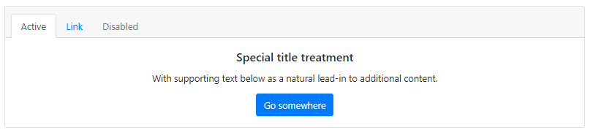

<div class="card text-center">

<div class="card-header">

<ul class="nav nav-tabs card-header-tabs">

<li class="nav-item">

<a class="nav-link active" href="#">Active</a>

</li>

<li class="nav-item">

<a class="nav-link" href="#">Link</a>

</li>

<li class="nav-item">

<a class="nav-link disabled" href="#" tabindex="-1" aria-disabled="true">Disabled</a>

</li>

</ul>

</div>

<div class="card-body">

<h5 class="card-title">Special title treatment</h5>

<p class="card-text">With supporting text below as a natural lead-in to additional content.</p>

<a href="#" class="btn btn-primary">Go somewhere</a>

</div>

</div>

## Images

Cards include a few options for working with images. Choose from appending “image caps” at either end of a card, overlaying images with card content, or simply embedding the image in a card.

### **Image caps**

Similar to headers and footers, cards can include top and bottom “image caps”—images at the top or bottom of a card.

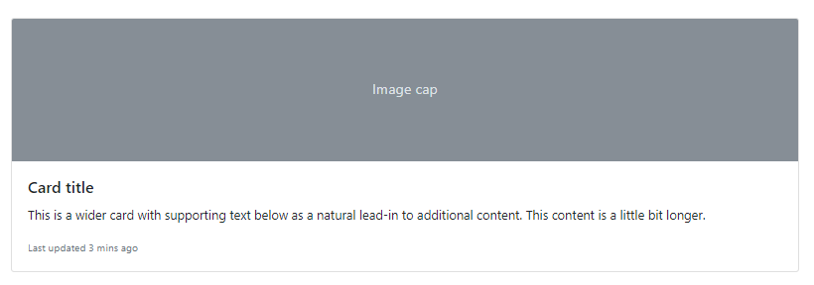

<div class="card mb-3">

<img src="..." class="card-img-top" alt="...">

<div class="card-body">

<h5 class="card-title">Card title</h5>

<p class="card-text">This is a wider card with supporting text below as a natural lead-in to additional content. This content is a little bit longer.</p>

<p class="card-text"><small class="text-muted">Last updated 3 mins ago</small></p>

</div>

</div>

<div class="card">

<div class="card-body">

<h5 class="card-title">Card title</h5>

<p class="card-text">This is a wider card with supporting text below as a natural lead-in to additional content. This content is a little bit longer.</p>

<p class="card-text"><small class="text-muted">Last updated 3 mins ago</small></p>

</div>

<img src="..." class="card-img-top" alt="...">

</div>

### **Image overlays**

Turn an image into a card background and overlay your card’s text. Depending on the image, you may or may not need additional styles or utilities.

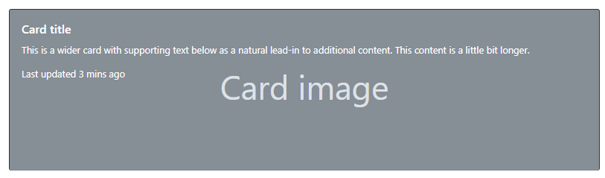

<div class="card bg-dark text-white">

<img src="..." class="card-img" alt="...">

<div class="card-img-overlay">

<h5 class="card-title">Card title</h5>

<p class="card-text">This is a wider card with supporting text below as a natural lead-in to additional content. This content is a little bit longer.</p>

<p class="card-text">Last updated 3 mins ago</p>

</div>

</div>

**Horizontal**

Using a combination of grid and utility classes, cards can be made horizontal in a mobile-friendly and responsive way. In the example below, we remove the grid gutters with .no-gutters and use .col-md-* classes to make the card horizontal at the md breakpoint. Further adjustments may be needed depending on your card content.

<div class="card mb-3" style="max-width: 540px;">

<div class="row no-gutters">

<div class="col-md-4">

<img src="..." class="card-img" alt="...">

</div>

<div class="col-md-8">

<div class="card-body">

<h5 class="card-title">Card title</h5>

<p class="card-text">This is a wider card with supporting text below as a natural lead-in to additional content. This content is a little bit longer.</p>

<p class="card-text"><small class="text-muted">Last updated 3 mins ago</small></p>

</div>

</div>

</div>

</div>

**Card styles**

Cards include various options for customizing their backgrounds, borders, and color.

### **Background and color**

Use [text and background utilities](https://getbootstrap.com/docs/4.4/utilities/colors/) to change the appearance of a card.

<div class="card text-white bg-primary mb-3" style="max-width: 18rem;">

<div class="card-header">Header</div>

<div class="card-body">

<h5 class="card-title">Primary card title</h5>

<p class="card-text">Some quick example text to build on the card title and make up the bulk of the card's content.</p>

</div>

</div>

<div class="card text-white bg-secondary mb-3" style="max-width: 18rem;">

<div class="card-header">Header</div>

<div class="card-body">

<h5 class="card-title">Secondary card title</h5>

<p class="card-text">Some quick example text to build on the card title and make up the bulk of the card's content.</p>

</div>

</div>

<div class="card text-white bg-success mb-3" style="max-width: 18rem;">

<div class="card-header">Header</div>

<div class="card-body">

<h5 class="card-title">Success card title</h5>

<p class="card-text">Some quick example text to build on the card title and make up the bulk of the card's content.</p>

</div>

</div>

<div class="card text-white bg-danger mb-3" style="max-width: 18rem;">

<div class="card-header">Header</div>

<div class="card-body">

<h5 class="card-title">Danger card title</h5>

<p class="card-text">Some quick example text to build on the card title and make up the bulk of the card's content.</p>

</div>

</div>

<div class="card text-white bg-warning mb-3" style="max-width: 18rem;">

<div class="card-header">Header</div>

<div class="card-body">

<h5 class="card-title">Warning card title</h5>

<p class="card-text">Some quick example text to build on the card title and make up the bulk of the card's content.</p>

</div>

</div>

<div class="card text-white bg-info mb-3" style="max-width: 18rem;">

<div class="card-header">Header</div>

<div class="card-body">

<h5 class="card-title">Info card title</h5>

<p class="card-text">Some quick example text to build on the card title and make up the bulk of the card's content.</p>

</div>

</div>

<div class="card bg-light mb-3" style="max-width: 18rem;">

<div class="card-header">Header</div>

<div class="card-body">

<h5 class="card-title">Light card title</h5>

<p class="card-text">Some quick example text to build on the card title and make up the bulk of the card's content.</p>

</div>

</div>

<div class="card text-white bg-dark mb-3" style="max-width: 18rem;">

<div class="card-header">Header</div>

<div class="card-body">

<h5 class="card-title">Dark card title</h5>

<p class="card-text">Some quick example text to build on the card title and make up the bulk of the card's content.</p>

</div>

</div>

### **Border**

Use [border utilities](https://getbootstrap.com/docs/4.4/utilities/borders/) to change just the border-color of a card. Note that you can put .text-{color} classes on the parent .card or a subset of the card’s contents as shown below.

<div class="card border-primary mb-3" style="max-width: 18rem;">

<div class="card-header">Header</div>

<div class="card-body text-primary">

<h5 class="card-title">Primary card title</h5>

<p class="card-text">Some quick example text to build on the card title and make up the bulk of the card's content.</p>

</div>

</div>

<div class="card border-secondary mb-3" style="max-width: 18rem;">

<div class="card-header">Header</div>

<div class="card-body text-secondary">

<h5 class="card-title">Secondary card title</h5>

<p class="card-text">Some quick example text to build on the card title and make up the bulk of the card's content.</p>

</div>

</div>

<div class="card border-success mb-3" style="max-width: 18rem;">

<div class="card-header">Header</div>

<div class="card-body text-success">

<h5 class="card-title">Success card title</h5>

<p class="card-text">Some quick example text to build on the card title and make up the bulk of the card's content.</p>

</div>

</div>

<div class="card border-danger mb-3" style="max-width: 18rem;">

<div class="card-header">Header</div>

<div class="card-body text-danger">

<h5 class="card-title">Danger card title</h5>

<p class="card-text">Some quick example text to build on the card title and make up the bulk of the card's content.</p>

</div>

</div>

<div class="card border-warning mb-3" style="max-width: 18rem;">

<div class="card-header">Header</div>

<div class="card-body text-warning">

<h5 class="card-title">Warning card title</h5>

<p class="card-text">Some quick example text to build on the card title and make up the bulk of the card's content.</p>

</div>

</div>

<div class="card border-info mb-3" style="max-width: 18rem;">

<div class="card-header">Header</div>

<div class="card-body text-info">

<h5 class="card-title">Info card title</h5>

<p class="card-text">Some quick example text to build on the card title and make up the bulk of the card's content.</p>

</div>

</div>

<div class="card border-light mb-3" style="max-width: 18rem;">

<div class="card-header">Header</div>

<div class="card-body">

<h5 class="card-title">Light card title</h5>

<p class="card-text">Some quick example text to build on the card title and make up the bulk of the card's content.</p>

</div>

</div>

<div class="card border-dark mb-3" style="max-width: 18rem;">

<div class="card-header">Header</div>

<div class="card-body text-dark">

<h5 class="card-title">Dark card title</h5>

<p class="card-text">Some quick example text to build on the card title and make up the bulk of the card's content.</p>

</div>

</div>

## Card layout

In addition to styling the content within cards, Bootstrap includes a few options for laying out series of cards. For the time being, **these layout options are not yet responsive**.

### **Card groups**

Use card groups to render cards as a single, attached element with equal width and height columns. Card groups use display: flex; to achieve their uniform sizing.

<div class="card-group">

<div class="card">

<img src="..." class="card-img-top" alt="...">

<div class="card-body">

<h5 class="card-title">Card title</h5>

<p class="card-text">This is a wider card with supporting text below as a natural lead-in to additional content. This content is a little bit longer.</p>

<p class="card-text"><small class="text-muted">Last updated 3 mins ago</small></p>

</div>

</div>

<div class="card">

<img src="..." class="card-img-top" alt="...">

<div class="card-body">

<h5 class="card-title">Card title</h5>

<p class="card-text">This card has supporting text below as a natural lead-in to additional content.</p>

<p class="card-text"><small class="text-muted">Last updated 3 mins ago</small></p>

</div>

</div>

<div class="card">

<img src="..." class="card-img-top" alt="...">

<div class="card-body">

<h5 class="card-title">Card title</h5>

<p class="card-text">This is a wider card with supporting text below as a natural lead-in to additional content. This card has even longer content than the first to show that equal height action.</p>

<p class="card-text"><small class="text-muted">Last updated 3 mins ago</small></p>

</div>

</div>

</div>

### **Grid cards**

Use the Bootstrap grid system and its [.row-cols classes](https://getbootstrap.com/docs/4.4/layout/grid/#row-columns) to control how many grid columns (wrapped around your cards) you show per row. For example, here’s .row-cols-1 laying out the cards on one column, and .row-cols-md-2 splitting four cards to equal width across multiple rows, from the medium breakpoint up.

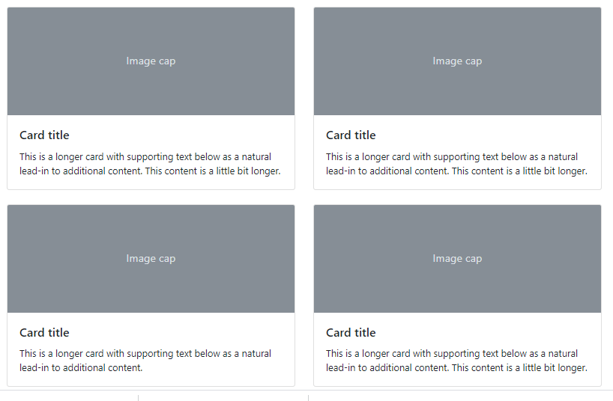

<div class="row row-cols-1 row-cols-md-2">

<div class="col mb-4">

<div class="card">

<img src="..." class="card-img-top" alt="...">

<div class="card-body">

<h5 class="card-title">Card title</h5>

<p class="card-text">This is a longer card with supporting text below as a natural lead-in to additional content. This content is a little bit longer.</p>

</div>

</div>

</div>

<div class="col mb-4">

<div class="card">

<img src="..." class="card-img-top" alt="...">

<div class="card-body">

<h5 class="card-title">Card title</h5>

<p class="card-text">This is a longer card with supporting text below as a natural lead-in to additional content. This content is a little bit longer.</p>

</div>

</div>

</div>

<div class="col mb-4">

<div class="card">

<img src="..." class="card-img-top" alt="...">

<div class="card-body">

<h5 class="card-title">Card title</h5>

<p class="card-text">This is a longer card with supporting text below as a natural lead-in to additional content.</p>

</div>

</div>

</div>

<div class="col mb-4">

<div class="card">

<img src="..." class="card-img-top" alt="...">

<div class="card-body">

<h5 class="card-title">Card title</h5>

<p class="card-text">This is a longer card with supporting text below as a natural lead-in to additional content. This content is a little bit longer.</p>

</div>

</div>

</div>

</div>

<div class="row row-cols-1 row-cols-md-3">

<div class="col mb-4">

<div class="card">

<img src="..." class="card-img-top" alt="...">

<div class="card-body">

<h5 class="card-title">Card title</h5>

<p class="card-text">This is a longer card with supporting text below as a natural lead-in to additional content. This content is a little bit longer.</p>

</div>

</div>

</div>

<div class="col mb-4">

<div class="card">

<img src="..." class="card-img-top" alt="...">

<div class="card-body">

<h5 class="card-title">Card title</h5>

<p class="card-text">This is a longer card with supporting text below as a natural lead-in to additional content. This content is a little bit longer.</p>

</div>

</div>

</div>

<div class="col mb-4">

<div class="card">

<img src="..." class="card-img-top" alt="...">

<div class="card-body">

<h5 class="card-title">Card title</h5>

<p class="card-text">This is a longer card with supporting text below as a natural lead-in to additional content.</p>

</div>

</div>

</div>

<div class="col mb-4">

<div class="card">

<img src="..." class="card-img-top" alt="...">

<div class="card-body">

<h5 class="card-title">Card title</h5>

<p class="card-text">This is a longer card with supporting text below as a natural lead-in to additional content. This content is a little bit longer.</p>

</div>

</div>

</div>

</div>

## Carousel

A slideshow component for cycling through elements—images or slides of text—like a carousel.

### **With controls**

Adding in the previous and next controls:

First slide



<div id="carouselExampleControls" class="carousel slide" data-ride="carousel">

<div class="carousel-inner">

<div class="carousel-item active">

<img src="..." class="d-block w-100" alt="...">

</div>

<div class="carousel-item">

<img src="..." class="d-block w-100" alt="...">

</div>

<div class="carousel-item">

<img src="..." class="d-block w-100" alt="...">

</div>

</div>

<a class="carousel-control-prev" href="#carouselExampleControls" role="button" data-slide="prev">

<span class="carousel-control-prev-icon" aria-hidden="true"></span>

<span class="sr-only">Previous</span>

</a>

<a class="carousel-control-next" href="#carouselExampleControls" role="button" data-slide="next">

<span class="carousel-control-next-icon" aria-hidden="true"></span>

<span class="sr-only">Next</span>

</a>

</div>

### **With indicators**

You can also add the indicators to the carousel, alongside the controls, too.



<div id="carouselExampleIndicators" class="carousel slide" data-ride="carousel">

<ol class="carousel-indicators">

<li data-target="#carouselExampleIndicators" data-slide-to="0" class="active"></li>

<li data-target="#carouselExampleIndicators" data-slide-to="1"></li>

<li data-target="#carouselExampleIndicators" data-slide-to="2"></li>

</ol>

<div class="carousel-inner">

<div class="carousel-item active">

<img src="..." class="d-block w-100" alt="...">

</div>

<div class="carousel-item">

<img src="..." class="d-block w-100" alt="...">

</div>

<div class="carousel-item">

<img src="..." class="d-block w-100" alt="...">

</div>

</div>

<a class="carousel-control-prev" href="#carouselExampleIndicators" role="button" data-slide="prev">

<span class="carousel-control-prev-icon" aria-hidden="true"></span>

<span class="sr-only">Previous</span>

</a>

<a class="carousel-control-next" href="#carouselExampleIndicators" role="button" data-slide="next">

<span class="carousel-control-next-icon" aria-hidden="true"></span>

<span class="sr-only">Next</span>

</a>

</div>

### **With captions**

Add captions to your slides easily with the .carousel-caption element within any .carousel-item. They can be easily hidden on smaller viewports, as shown below, with optional [display utilities](https://getbootstrap.com/docs/4.4/utilities/display/). We hide them initially with .d-none and bring them back on medium-sized devices with .d-md-block.

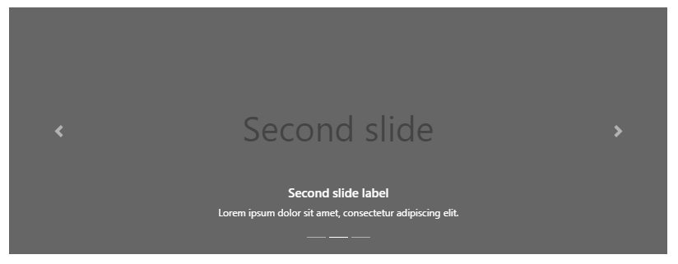

<div id="carouselExampleCaptions" class="carousel slide" data-ride="carousel">

<ol class="carousel-indicators">

<li data-target="#carouselExampleCaptions" data-slide-to="0" class="active"></li>

<li data-target="#carouselExampleCaptions" data-slide-to="1"></li>

<li data-target="#carouselExampleCaptions" data-slide-to="2"></li>

</ol>

<div class="carousel-inner">

<div class="carousel-item active">

<img src="..." class="d-block h-75 w-100" alt="...">

<div class="carousel-caption d-none d-md-block">

<h5>First slide label</h5>

<p>Nulla vitae elit libero, a pharetra augue mollis interdum.</p>

</div>

</div>

<div class="carousel-item">

<img src="..." class="d-block h-75 w-100" alt="...">

<div class="carousel-caption d-none d-md-block">

<h5>Second slide label</h5>

<p>Lorem ipsum dolor sit amet, consectetur adipiscing elit.</p>

</div>

</div>

<div class="carousel-item">

<img src="..." class="d-block h-75 w-100" alt="...">

<div class="carousel-caption d-none d-md-block">

<h5>Third slide label</h5>

<p>Praesent commodo cursus magna, vel scelerisque nisl consectetur.</p>

</div>

</div>

</div>

<a class="carousel-control-prev" href="#carouselExampleCaptions" role="button" data-slide="prev">

<span class="carousel-control-prev-icon" aria-hidden="true"></span>

<span class="sr-only">Previous</span>

</a>

<a class="carousel-control-next" href="#carouselExampleCaptions" role="button" data-slide="next">

<span class="carousel-control-next-icon" aria-hidden="true"></span>

<span class="sr-only">Next</span>

</a>

</div>

## Accordion example

Using the [card](https://getbootstrap.com/docs/4.4/components/card/) component, you can extend the default collapse behavior to create an accordion. To properly achieve the accordion style, be sure to use .accordion as a wrapper.

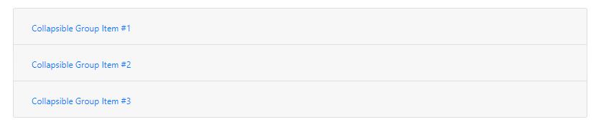

<div class="accordion" id="accordionExample">

<div class="card">

<div class="card-header" id="headingOne">

<h2 class="mb-0">

<button class="btn btn-link" type="button" data-toggle="collapse" data-target="#collapseOne" aria-expanded="true" aria-controls="collapseOne">

Collapsible Group Item #1

</button>

</h2>

</div>

<div id="collapseOne" class="collapse show" aria-labelledby="headingOne" data-parent="#accordionExample">

<div class="card-body">

Anim pariatur cliche reprehenderit, enim eiusmod high life accusamus terry richardson ad squid. 3 wolf moon officia aute, non cupidatat skateboard dolor brunch. Food truck quinoa nesciunt laborum eiusmod. Brunch 3 wolf moon tempor, sunt aliqua put a bird on it squid single-origin coffee nulla assumenda shoreditch et. Nihil anim keffiyeh helvetica, craft beer labore wes anderson cred nesciunt sapiente ea proident. Ad vegan excepteur butcher vice lomo. Leggings occaecat craft beer farm-to-table, raw denim aesthetic synth nesciunt you probably haven't heard of them accusamus labore sustainable VHS.

</div>

</div>

</div>

<div class="card">

<div class="card-header" id="headingTwo">

<h2 class="mb-0">

<button class="btn btn-link collapsed" type="button" data-toggle="collapse" data-target="#collapseTwo" aria-expanded="false" aria-controls="collapseTwo">

Collapsible Group Item #2

</button>

</h2>

</div>

<div id="collapseTwo" class="collapse" aria-labelledby="headingTwo" data-parent="#accordionExample">

<div class="card-body">

Anim pariatur cliche reprehenderit, enim eiusmod high life accusamus terry richardson ad squid. 3 wolf moon officia aute, non cupidatat skateboard dolor brunch. Food truck quinoa nesciunt laborum eiusmod. Brunch 3 wolf moon tempor, sunt aliqua put a bird on it squid single-origin coffee nulla assumenda shoreditch et. Nihil anim keffiyeh helvetica, craft beer labore wes anderson cred nesciunt sapiente ea proident. Ad vegan excepteur butcher vice lomo. Leggings occaecat craft beer farm-to-table, raw denim aesthetic synth nesciunt you probably haven't heard of them accusamus labore sustainable VHS.

</div>

</div>

</div>

<div class="card">

<div class="card-header" id="headingThree">

<h2 class="mb-0">

<button class="btn btn-link collapsed" type="button" data-toggle="collapse" data-target="#collapseThree" aria-expanded="false" aria-controls="collapseThree">

Collapsible Group Item #3

</button>

</h2>

</div>

<div id="collapseThree" class="collapse" aria-labelledby="headingThree" data-parent="#accordionExample">

<div class="card-body">

Anim pariatur cliche reprehenderit, enim eiusmod high life accusamus terry richardson ad squid. 3 wolf moon officia aute, non cupidatat skateboard dolor brunch. Food truck quinoa nesciunt laborum eiusmod. Brunch 3 wolf moon tempor, sunt aliqua put a bird on it squid single-origin coffee nulla assumenda shoreditch et. Nihil anim keffiyeh helvetica, craft beer labore wes anderson cred nesciunt sapiente ea proident. Ad vegan excepteur butcher vice lomo. Leggings occaecat craft beer farm-to-table, raw denim aesthetic synth nesciunt you probably haven't heard of them accusamus labore sustainable VHS.

</div>

</div>

</div>

</div>

## Jumbotron

Lightweight, flexible component for showcasing hero unit style content.

A lightweight, flexible component that can optionally extend the entire viewport to showcase key marketing messages on your site.

div class="jumbotron">

<h1 class="display-4">Hello, world!</h1>

<p class="lead">This is a simple hero unit, a simple jumbotron-style component for calling extra attention to featured content or information.</p>

<hr class="my-4">

<p>It uses utility classes for typography and spacing to space content out within the larger container.</p>

<a class="btn btn-primary btn-lg" href="#" role="button">Learn more</a>

</div>

## Navs

Documentation and examples for how to use Bootstrap’s included navigation components.

**Base nav**

Navigation available in Bootstrap share general markup and styles, from the base .nav class to the active and disabled states. Swap modifier classes to switch between each style.

The base .nav component is built with flexbox and provide a strong foundation for building all types of navigation components. It includes some style overrides (for working with lists), some link padding for larger hit areas, and basic disabled styling.

<ul class="nav">

<li class="nav-item">

<a class="nav-link active" href="#">Active</a>

</li>

<li class="nav-item">

<a class="nav-link" href="#">Link</a>

</li>

<li class="nav-item">

<a class="nav-link" href="#">Link</a>

</li>

<li class="nav-item">

<a class="nav-link disabled" href="#" tabindex="-1" aria-disabled="true">Disabled</a>

</li>

</ul>

### **Horizontal alignment**

Change the horizontal alignment of your nav with [flexbox utilities](https://getbootstrap.com/docs/4.4/layout/grid/" \l "horizontal-alignment). By default, navs are left-aligned, but you can easily change them to center or right aligned.

Centered with .justify-content-center:



ul class="nav justify-content-center">

<li class="nav-item">

<a class="nav-link active" href="#">Active</a>

</li>

<li class="nav-item">

<a class="nav-link" href="#">Link</a>

</li>

<li class="nav-item">

<a class="nav-link" href="#">Link</a>

</li>

<li class="nav-item">

<a class="nav-link disabled" href="#" tabindex="-1" aria-disabled="true">Disabled</a>

</li>

</ul>



<ul class="nav justify-content-end">

<li class="nav-item">

<a class="nav-link active" href="#">Active</a>

</li>

<li class="nav-item">

<a class="nav-link" href="#">Link</a>

</li>

<li class="nav-item">

<a class="nav-link" href="#">Link</a>

</li>

<li class="nav-item">

<a class="nav-link disabled" href="#" tabindex="-1" aria-disabled="true">Disabled</a>

</li>

</ul>

### **Tabs**

Takes the basic nav from above and adds the .nav-tabs class to generate a tabbed interface. Use them to create tabbable regions with our [tab JavaScript plugin](https://getbootstrap.com/docs/4.4/components/navs/" \l "javascript-behavior).



<ul class="nav nav-tabs">

<li class="nav-item">

<a class="nav-link active" href="#">Active</a>

</li>

<li class="nav-item">

<a class="nav-link" href="#">Link</a>

</li>

<li class="nav-item">

<a class="nav-link" href="#">Link</a>

</li>

<li class="nav-item">

<a class="nav-link disabled" href="#" tabindex="-1" aria-disabled="true">Disabled</a>

</li>

</ul>

## Navbar

Documentation and examples for Bootstrap’s powerful, responsive navigation header, the navbar. Includes support for branding, navigation, and more, including support for our collapse plugin.



<nav class="navbar navbar-expand-lg navbar-light bg-light">

<a class="navbar-brand" href="#">Navbar</a>

<button class="navbar-toggler" type="button" data-toggle="collapse" data-target="#navbarSupportedContent" aria-controls="navbarSupportedContent" aria-expanded="false" aria-label="Toggle navigation">

<span class="navbar-toggler-icon"></span>

</button>

<div class="collapse navbar-collapse" id="navbarSupportedContent">

<ul class="navbar-nav mr-auto">

<li class="nav-item active">

<a class="nav-link" href="#">Home <span class="sr-only">(current)</span></a>

</li>

<li class="nav-item">

<a class="nav-link" href="#">Link</a>

</li>

<li class="nav-item dropdown">

<a class="nav-link dropdown-toggle" href="#" id="navbarDropdown" role="button" data-toggle="dropdown" aria-haspopup="true" aria-expanded="false">

Dropdown

</a>

<div class="dropdown-menu" aria-labelledby="navbarDropdown">

<a class="dropdown-item" href="#">Action</a>

<a class="dropdown-item" href="#">Another action</a>

<div class="dropdown-divider"></div>

<a class="dropdown-item" href="#">Something else here</a>

</div>

</li>

<li class="nav-item">

<a class="nav-link disabled" href="#" tabindex="-1" aria-disabled="true">Disabled</a>

</li>

</ul>

<form class="form-inline my-2 my-lg-0">

<input class="form-control mr-sm-2" type="search" placeholder="Search" aria-label="Search">

<button class="btn btn-outline-success my-2 my-sm-0" type="submit">Search</button>

</form>

</div>

</nav>



<!-- Image and text -->

<nav class="navbar navbar-light bg-light">

<a class="navbar-brand" href="#">

<img src="/docs/4.4/assets/brand/bootstrap-solid.svg" width="30" height="30" class="d-inline-block align-top" alt="">

Bootstrap

</a>

</nav>



<nav class="navbar navbar-expand-lg navbar-light bg-light">

<a class="navbar-brand" href="#">Navbar</a>

<button class="navbar-toggler" type="button" data-toggle="collapse" data-target="#navbarNav" aria-controls="navbarNav" aria-expanded="false" aria-label="Toggle navigation">

<span class="navbar-toggler-icon"></span>

</button>

<div class="collapse navbar-collapse" id="navbarNav">

<ul class="navbar-nav">

<li class="nav-item active">

<a class="nav-link" href="#">Home <span class="sr-only">(current)</span></a>

</li>

<li class="nav-item">

<a class="nav-link" href="#">Features</a>

</li>

<li class="nav-item">

<a class="nav-link" href="#">Pricing</a>

</li>

<li class="nav-item">

<a class="nav-link disabled" href="#" tabindex="-1" aria-disabled="true">Disabled</a>

</li>

</ul>

</div>

</nav>

**Color schemes**

Theming the navbar has never been easier thanks to the combination of theming classes and background-color utilities. Choose from .navbar-light for use with light background colors, or .navbar-dark for dark background colors. Then, customize with .bg-* utilities.

<nav class="navbar navbar-dark bg-dark">

<!-- Navbar content -->

</nav>

<nav class="navbar navbar-dark bg-primary">

<!-- Navbar content -->

</nav>

<nav class="navbar navbar-light" style="background-color: #e3f2fd;">

<!-- Navbar content -->

</nav>

## FOOTER



<!-- Footer -->

<footer class="blockquote-footer ">

<div class="text-center">© 2020 Copyright: </div>

</footer>

<!-- Footer -->